How to enable macros in excel?
- Open excel sheet
- Click on office Button on left hand side corner and click on Excel Option there..

And then this window will popup
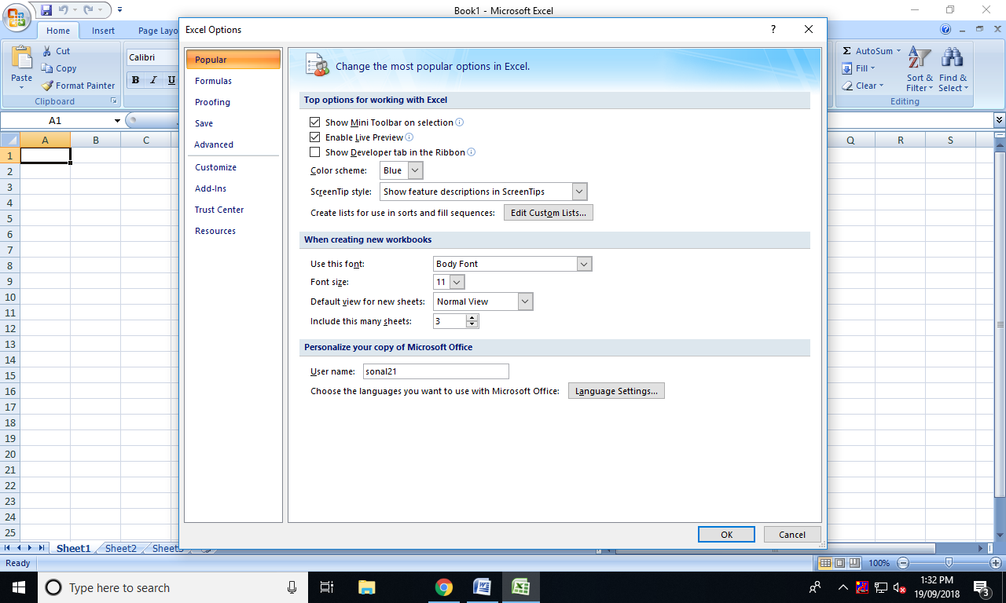
- Then click on Trust Center .. and on the same window click on Trust Center Setting.. then this window will popup..
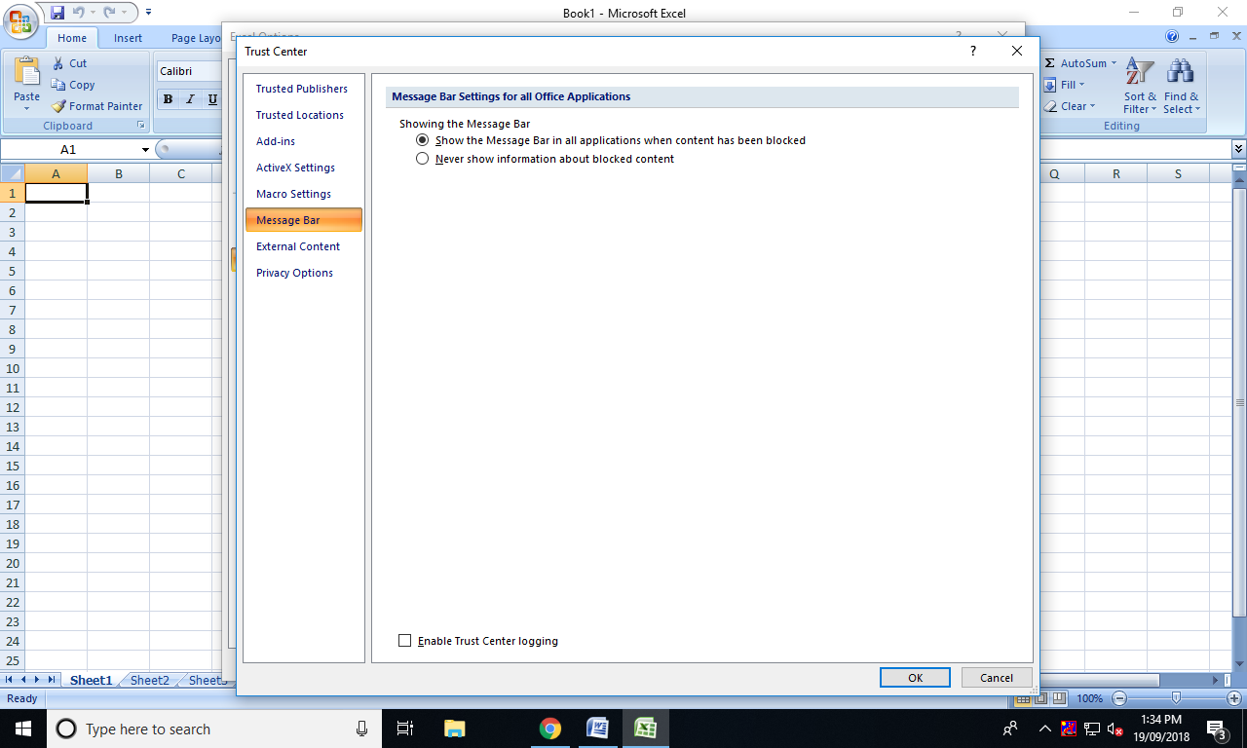

- There after click on Macro Settings and Click on Enable all macros and then OK.. and its done..
